Above & Beyond Doors
Above & Beyond Doors

20% Discount for all Forsyth County School Faculty & Staff Members

Above and Beyond Doors is a locally owned and operated business. We have been operating in the Cumming and surrounding area for the last 5yrs. This offer is valid for the next 2 full calendar years. We look forward to hearing from you for all your door needs.

Thank You
Ryan Frank
Owner
-Free Estimates
-Broken springs
-Damaged Doors
-New Installation
-Openers-
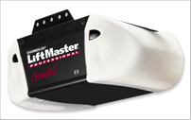

-And many more brands.
-Entry Doors
-Storm Doors
-Shower Doors
-Gated Entry Drives

Phone: 770-Garages/ (770-427-2437)
Or
Email: 770Garages@gmail.com

Offer expires: 9/7/2014

